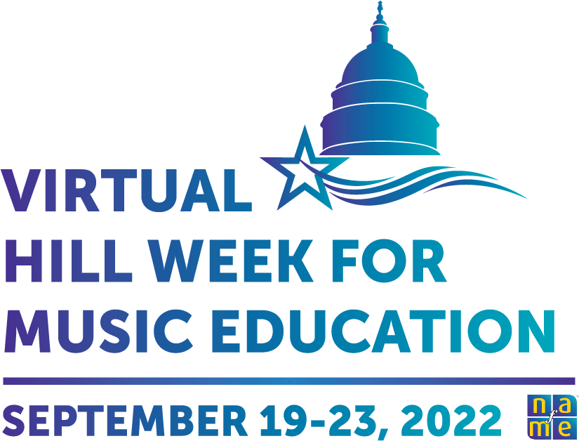

Fiscal Year 2023 (FY 2023) Fact Sheet

The National Association for Music Education (NAfME) is among the world’s largest arts education organizations, representing more than 53,000 music educators and music advocates across the United States. Our goal is to ensure that every student has access to a well-balanced, comprehensive, and high-quality program of music instruction taught by qualified teachers. The passage of the Every Student Succeeds Act (ESSA) designated music as part of a “Well-Rounded Education,” providing opportunities for increased student access to music education. The commitment to a well-rounded education that includes music education is more important than ever as students return to school increasingly in need of environments that support their social, emotional, and academic development.

To reinforce the positive impacts that music education has on students, we urge Congress to support the following funding proposals and legislation.

**Student Support**

* **Title I, Part A—**Provides funds to school districts to help disadvantaged children achieve proficiency on challenging academic standards and improve the performance of low-achieving schools.
  + We request this program be funded at **$36.5 billion** in FY 2023.
  + We also request Congress to include language in the annual Labor-HHS-Education bill directing the U.S. Department of Education to issue guidance for states and districts on the use of Title I funds to support music education as part of a “well-rounded education.”
* **Title IV, Part A—**A flexible block grant program which supports activities in three broad areas:

(1) providing students with a well-rounded education (e.g., college and career counseling, STEM, arts and music, civics, advanced placement); (2) supporting safe and healthy students (e.g., comprehensive school mental health, drug and violence prevention, health and physical education); and (3) supporting the effective use of technology.

* + We request this program be funded at **$2 billion** in FY 2023.
* **The Nita Lowey 21st Century Community Learning Centers—**A formula grant program that provides financial support to local communities for afterschool, before-school, and summer learning programs serving students in low-performing schools. Programs are provided three- to five-year seed grants that support partnerships among community-based organizations, faith- based partners, private providers, and school partners (public, private, and charter).
  + We request this program be funded at **$1.8 billion** in FY 2023.
* **Individuals with Disabilities Education Act (IDEA) State Grant program (Part B)—**Provides special education services and supports to 7.4 million eligible children with disabilities to ensure a free and appropriate public education.
  + We request this program be funded at **$16.3 billion** in FY 2023.

**Supporting an Experienced and Diverse Educator Workforce**

* **Title II, Part A—**Focuses on improving student academic achievement by bolstering skills and expertise of teachers, principals, and other educators and increasing the number of high-quality teachers and principals in schools.
  + We request this program be funded at **$3 billion** in FY 2023.
  + We also request Congress to include language in the annual Labor-HHS-Education bill directing the U.S. Department of Education to issue guidance for states and districts on the use of Title II funds to support professional learning opportunities for music and other arts educators.
* **Augustus F. Hawkins Center for Excellence program—**Designed to support comprehensive teacher preparation at programs at Historically Black Colleges and Universities (HBCUs), Tribal Colleges and Universities (TCUs), and minority-serving institutions (MSIs).
  + We request this program be funded at **$300 million** in FY 2023.
* **Education Innovation and Research Program (EIR)—**Provides grant funding to support educator leadership, the earning of high-need and advanced certifications and credentials, and improved school structures to support teaching and learning.
  + We request this program be funded at **$320 million** in FY 2023.
* **Individuals with Disabilities Education Act (IDEA) State Grant program (Part D)—**Designed to comprehensively prepare specialized instructional support personnel, special educators, early educators, and the higher education faculty and researchers that support their preparation.
  + We request this program be funded at **$300 million** in FY 2023.
* **Teacher Quality Partnership (TQP) Grant Program—**Funds comprehensive educator preparation programs at institutions of higher education.
  + We request this program be funded at **$1 billion** in FY 2023.

**Support for Music and the Arts**

* **Assistance for Arts Education program—**Promotes arts education for all students, through activities such as professional development for arts educators; development and dissemination of accessible instructional materials; and community and national outreach activities that strengthen and expand partnerships among schools, local education agencies, and centers for the arts.
  + We request this program be funded at **$40 million** in FY 2023.
* **National Endowment for the Arts (NEA)—**Advances equitable opportunities for the arts participations and practice as the largest funders of the arts and arts education.
  + We request this agency be funded at **$203.5 million** in FY 2023.
* **IES National Assessment for Educational Progress—**Also known as the “Nation’s Report Card,” provides important information about student achievement and learning experiences in various subjects to improve education policy and practice.
  + We support funding at a level sufficient in FY 2023 to include the arts, economics, foreign (world) languages, and geography as part of the annual Nation’s Report Card.

**Additional Support**

* **Institute of Education Sciences (IES) Fast Response Survey System (FRSS)—**Nation’s Report Card. Collects issue-oriented data from state educational agencies and national samples of other educational organizations and participants, including districts, and public and private elementary and secondary schools, teachers, and principals, and public libraries.
  + We request at least **$4 million** for IES in FY 2023 to implement an FRSS study in the arts that includes information on access to a wide variety of music education programs.
* **U.S. Department of Education (ED) Salaries & Expenses**
  + To help oversee the appropriate use of the funds requested as part of our legislative agenda to support music and the arts, we request that ED receive ample funding in FY 2023 to increase its employee count to include three senior-level content advisors, one each for music and the arts, humanities, and social studies. These positions can support department-wide policymaking and reporting for our subject areas. This request is modeled on prior Special Assistants in the Arts positions that existed over the past two decades at ED.

**Federal Legislation**

* **Arts Education for All Act (H.R. 5581) sponsored by Representative Suzanne Bonamici**
  + The Arts Education for All Act would expand arts education and programming to America’s youngest learners, K-12 students, and youths impacted by the juvenile justice system. The bill includes provisions to support the professional development of arts educators and to amend the ESEA in order to provide more oversight into the implementation of arts education programs. The bill also requires research on the use of arts in education by the National Center for Education Research and the collection of data on arts education by the National Center for Education Statistics.
* **Advancing Equity Through the Arts and Humanities Act (H.R 7627) sponsored by Representative Barbara Lee**
* The Advancing Equity Through the Arts and Humanities Act will create the “Advancing Equity Through the Arts and Humanities Program” to be carried out by the Chair of the National Endowment for the Arts (NEA) and the National Endowment for the Humanities (NEH). The program is aimed at increasing engagement with public and nonprofit entities, including faith based and community-based organizations, that serve and are led by people of color, and to support arts and humanities projects that directly combat systemic racism.
  + Program will build and implement a competitive grant that will directly combat systemic racism through the arts and humanities, no later than 180 days after the passage of this bill.
  + Priority for the grant will be given to public and non-profit organizations that are BIPOC-led, have majority BIPOC membership, or who have a proven history of effective antiracism work and shows a commitment to supporting the BIPOC community.
* **Reopen and Rebuild America’s Schools Act (S.96) (H.R.604) sponsored by Senator Jack Reed and Representative Robert C. Scott**
* The Reopen and Rebuild America’s Schools Act would create a $100 billion grant program and $30 billion tax credit bond program targeted at high-poverty schools with facilities that pose health and safety risks to students and staff.
  + - The allowable uses of grant funds, includes carrying out major repairs, improving indoor air quality, making facilities accessible to disabled individuals, and the renovation or development of music facilities.

