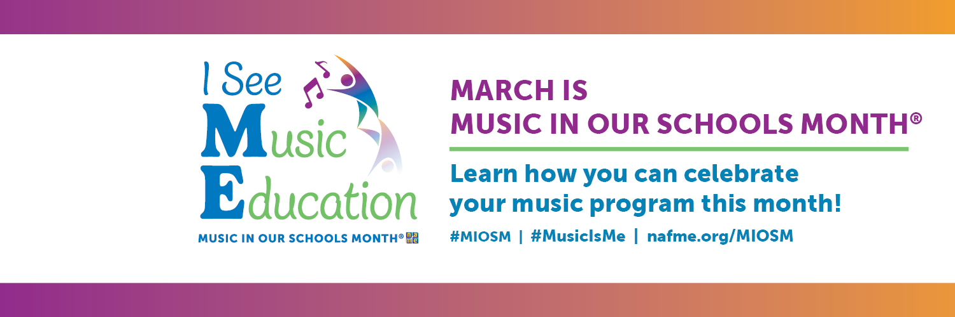
Proclamation Sample:
Governor/ Principal
WHEREAS, for more than 30 years, March has been officially designated by the National Association for Music Education (NAfME) as Music In Our Schools Month® (MIOSM®), encouraging communities across the nation to focus on music education; and
WHEREAS, music education is part of a well-rounded education for every student as outlined in the Every Student Succeeds Act; and
WHEREAS, the purpose of this celebration is to raise awareness of the lasting positive impact of music education on the academic, personal, and professional growth of our students; and
WHEREAS, music education shapes the way our students understand themselves and the world around them, allowing for a deep engagement with learning; and
WHEREAS, Music In Our Schools Month® reminds us that school is where all children should have access to music; and
WHEREAS, music educators, students and communities throughout [STATE] demonstrate the importance of quality music education programs to the lives of young people
WHEREAS, the state of _____________ joins our music students, educators and communities in celebrating the power of music education;
NOW, THEREFORE, I [NAME, Title], do hereby proclaim March as “Music In Our Schools Month®” in [STATE] and encourage all citizens to celebrate and acknowledge everyday but especially in March that Music Education is an essential part of every student’s well-rounded education.
Placeholder for
Seal or Logo

[NAME]

[TITLE]

