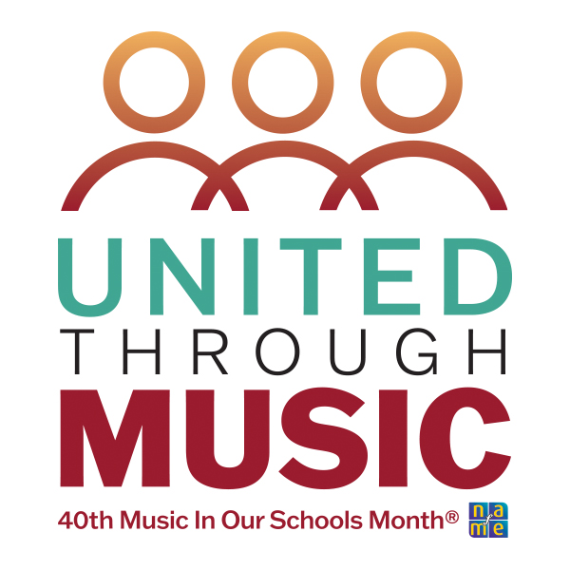

Multiliterate Approach to Chord Lyric Notation in Class Guitar

Dr. Aaron Lohmeyer, Winona State University
Grade Level: Middle-High
Date: 1.9.2025

About the lesson:

Guitar classrooms are an ideal place to explore the concept of multiliteracy. Multiliteracy posits that a contemporary literacy curriculum should invite the reader to negotiate and create utilizing a multitude of text modalities across a variety of communities of practice. Not only does this develop flexible musicianship, but it allows the reader to explore different approaches to musical organization. Working guitarists are often great examples of “multiliteracy” because they often read an array of music media forms, such as tablature, staff notation, lead sheets, chord-lyric notation, and audio recordings, while performing across many different styles. This lesson uses chord-lyric notation as a text modality to explore learning by ear while also exploring the variety of ways working musicians may utilize this music media design for music learning.

Source: “Chasing Cars” by Snow Patrol

Materials needed:

Lyrics to the first verse and chorus of “Chasing Cars” by Snow Patrol
Blank tablature paper
Any digital transposing function like Google Chrome’s Transpose or the pitch adjust feature in a digital audio workstation.

Procedure:

Anticipatory Set
- Warmup on the G major scale in open position.
- Present the song “Chasing Cars” as a I–IV–V play-along activity with the recording in G.
(The original is in A, but a -2 pitch shift makes this work as a I–IV–V in G.)
- As an optional challenge, offer the main riff in tablature notation for students desiring an added plectrum or fingerpick challenge.

Main riff:

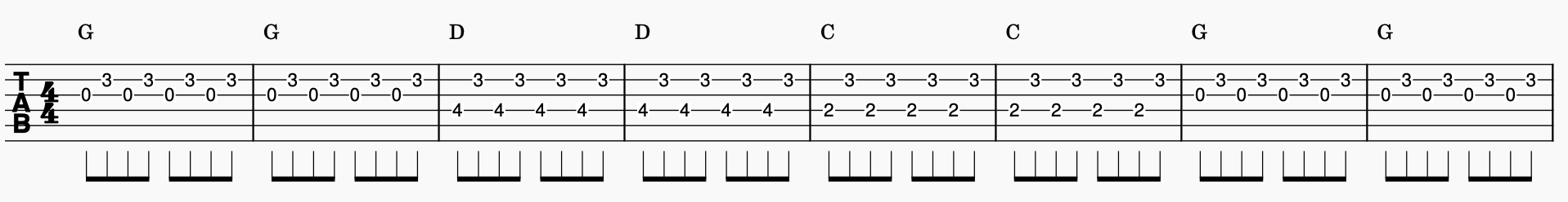

Instructional Input
- Lyrics to the first verse are provided to the students.
- Instructor sets a loop to the first verse of the song and performs the sung melody on the guitar.
- Students close eyes and hum this melody while viewing the lyrics, isolating the pitch movement.
- Instructor draws pitch contour lines above the words providing a contour outline of the melody.
- Essential question is posed: Which notes of the G major scale are used to create the lyrical melody?

Model
- Instructor writes in the first line of notes above the melody.
EX:

G B F# G
We’ll do it all.

Check for Understanding
- Students play the short melody to “We’ll do it all” and are asked to figure out the next line of the lyrical melody (“Everything”) with a partner.
- Students sing what they believe to be the answer (B F# E).
- If correct, students write in the next line of notes above the words.

Practice
- Students transcribe the melody for first verse of “Chasing Cars.”
- Teacher checks answers. If correct, students are to practice playing the melody to the verse while vocalizing quietly as they feel comfortable. (If singing is uncomfortable for your class, encourage soft humming to encourage foundational pitch-matching skills).

Closure
- Divide the class into melody and chord groups.
- Perform the song trading melody and harmonic accompaniment roles between repetitions.

Educational Objective:

By the end of this lesson students will have developed a process to use both audio recording and chord lyric notation to transcribe simple melodies, transcribed a popular melody, and applied this work toward a simple informal performance. Additionally, students will have utilized multiple music media designs, including chord symbols, tablature, chord lyric sheets, and audio recordings, demonstrating the integrated practices of multiliteracy.

Music Standard Utilized:

CREATING | Anchor Standard  2: Organize and develop artistic ideas and work. | Process Component:  MU:Cr2.1.H.8a Select, develop, and use standard notation and audio/video recording to document melodic, rhythmic, and harmonic ideas for drafts of melodies (created over specified chord progressions or AB / ABA forms) and two-to-three-chord accompaniments for given melodies.
http://www.nationalartsstandards.org/
http://www.nafme.org/my-classroom/standards/core-music-standards/
https://www.cde.ca.gov/be/st/ss/vapacontentstds.asp

Cognitive Learning | A multiliteracy approach employs multiple cognitive functions as students construct an understanding of one concept (melody, in this example) across multiple media modalities. In the above, students accessed a familiar melody from their own aural library (remember), isolated the syntactical feature of melody through singing and playing (understand), transcribed onto guitar and notation their aural understandings using a limited pitch set (apply), and compared their work with peers as they assessed their own learning (evaluate). Finally, students were given the opportunity to perform the outcome of this learning in a simple class ensemble playing activity.
Universal Design for Learning (UDL)  https://udlguidelines.cast.org/ | By design, a multiliteracy approach seeks out multiple means of action, expression, and representation. In the above, as students worked to perceive melody, students listened, hummed, wrote a contour, labeled with pitch names, read with tablature, and performed from their own notated document.

