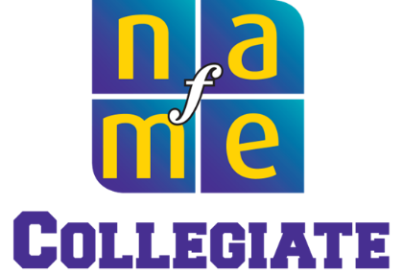

**Requesting Funds for CLAS**

*Email Template*

|  |
| --- |
| This email template may be helpful as you draft your requests for funding for the **NAfME Collegiate Leadership Advocacy Summit (CLAS)**. Please feel free to edit the letter to best meet your needs. Before you submit, have your letter proofread by your Chapter Advisor or another faculty member. |

Dear ___________________ ,

My name is __________ __________, and I am a member of the XYZ College/University NAfME Collegiate Chapter. I am writing to request full or partial funding to attend the 2025 NAfME Collegiate Leadership Advocacy Summit (CLAS) in Washington, DC, June 9–11.

This event is an opportunity to network and collaborate with collegiate music education students from around the United States through a variety of robust leadership and advocacy-centric learning sessions led by music education leaders.

The event concludes with NAfME’s annual Hill Day, an in-person advocacy event on Capitol Hill during which attendees participate in meetings with U.S. Representatives and Senators and staffers to advocate on behalf of music education at the federal level.

The total cost for this event—including registration, travel, and lodging—is $_.__. The positive impact of my attendance at this event on me, my NAfME Collegiate Chapter, and my music education community would be massive! Below are some examples of how I intend to share this impact:

* Represent [your college/university] on the national level for music education
* Presentation to my chapter on what I learned
* Lead advocacy efforts in my community
* Pave the way for another chapter member to attend in the future
* Submit a presentation to my state music education association conference on the impact this event had on me and what I learned to advance the music education profession
* *Adapt any of the above reasons to attend, or create any others*

Option 1: Attached is an agenda for the 2025 CLAS so you may see the opportunities in store for me should I be able to attend, and I encourage you to read about last year’s Summit in [this blog](https://nafme.org/blog/the-2024-nafme-collegiate-leadership-advocacy-summit/) detailing the activities.

Option 2: The agenda for the 2025 CLAS is being finalized, but please see attached for the 2024 CLAS agenda so you may see an idea of the opportunities in store for me. I’ll be glad to share the 2025 agenda as soon as it’s available. I encourage you to read about last year’s Summit in [this blog](https://nafme.org/blog/the-2024-nafme-collegiate-leadership-advocacy-summit/) detailing the activities.

Thank you for taking the time to consider my request. I look forward to hearing from you.

Sincerely,