

Music In Our Schools Month Lesson for First Grade
Curriculum Design: Using the Same Repertoire for Many Purposes

Submitted by Rob Lyda, PhD NAfME General Music Council Immediate Past Chair

Objectives:
- Students will identify and label rests in a familiar song.

Materials, Equipment, Books
- Bow Wow Wow Tap Sheet
- 6 Foot Parachute

Repertoire
- Bow Wow Wow

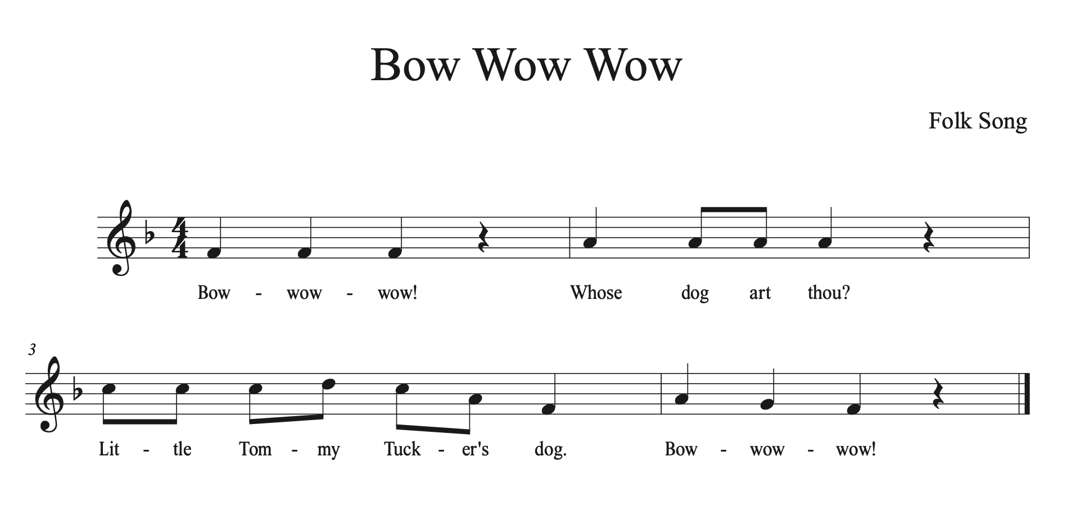
Lesson Procedure
Lesson Segment 1
- Ask the students, “How many dogs are too many dogs to have as pets?”
- Tell the students that you know a person with 16 dogs!
- Brainstorm with the students what it would be like to have 16 dogs living in their home.
- Teach the song “Bow Wow Wow”.
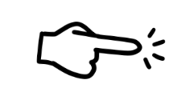
- Teach basic movements to accompany the song while standing in place.

Bow Wow Wow! - Point finger to the beat
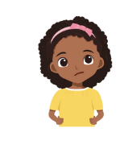
Whose dog art thou? - Questioning hands
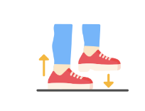
Little Tommy Tucker’s dog. - Hand on your hips
Bow Wow Wow! - Stamping feet three times

Lesson Segment 2
- Review the song and basic movements for Bow Wow Wow with the students.
- Remind the students that Tommy Tucker has 16 dogs.
- Show the students the Bow Wow Wow tap sheet. Have the students point to each dog and count to 16.
- Ask the students, “Do you think 16 dogs will make a lot of noise?” Discuss the students’ answers.
- Ask the students to tap each dog on the tap sheet again, but instead of counting numbers have the students say, “Woof”.
- Tell the students that you noticed there is something special about some of the dogs on the tap sheet. Ask the students to tap and “woof” again while you sing Bow Wow Wow. You could also have half the class sing Bow Wow Wow while the other half of the class points to each dog and says“woof”.
- Ask the students if they noticed anything different about some of the dogs? It may take signing and “woofing” a few times for the students to notice.
- Explain to the students that the different looking dogs at the end of rows 1, 2, and 4 are silent dogs. They do not woof; instead they go into their dog house and take a rest. Put the dog house icon on top of the different looking dogs at the end of rows 1, 2, and 4. Have the students tap and “woof” again, this time omitting the “woof” when they tap the dog houses at the end of rows 1, 2, and 4.
- Explain to the students that when there is silence on a beat it is called a rest. Show the students your preferred notation symbol for rest. I would also suggest having the students find a non-locomotor way to show the rest beat.

Lesson Segment 3
- Review the song and basic movements for Bow Wow Wow with the students.
- Ask the students if they remember what it is called when there is silence on a beat of music.
- Explain to the students that you are going to change some of the movements learned in previous classes. Have the students try the new movements with a partner.
Bow Wow Wow! - Point to the beat
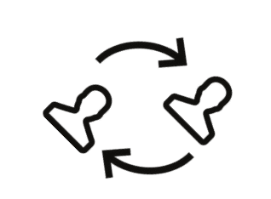
Whose dog art thou? - Questioning hands
Little Tommy Tucker’s dog. - Hold hands with your partner and switch places.

Bow Wow Wow! - Stamp feet three times and jump on the rest turning away from partners

- Practice singing the song with the new movements. Explain to the students that the new movements make Bow Wow Wow a game.
- Place the parachute on the floor. Have the students gather around the perimeter of the parachute with their partner. Tell the student to face their partner. Slowly practice the song and the new movements while standing around the parachute. It may take a few times for the students to get the hang of stamping their feet three times and jumping away from their partner on the rest. Once the students can successfully sing and move, have the students continue playing the singing game while moving around the circle. You should sing and play the game until the students move around the circle and end with their original partner.

Adjusting objectives to reuse repertoire for second grade:
- Students will ask to play this game again and again! I keep this game in my “bag of tricks” to pull out when we have a few minutes left at the end of class.
- The primary focus of introducing Bow Wow Wow in first grade is to label and practice quarter rest. I reintroduce Bow Wow Wow to second grade students after we label mi-re-do. The last measure provides a perfect example of the descending mi-re-do motive for the students to recognize.
- Instead of singing the words to Bow Wow Wow to my second graders, I sing the melody on a neutral syllable and ask the students to identify the song. I challenge the students to figure out the solfége syllables for the melody. I will give the students the starting pitch (do) and allow them to work with partners to figure out the remaining syllables. In addition, I often use a graphic organizer to help the students figure out the solfége syllables for the melody. See two examples of graphic organizers at the end of this packet that students can use.

Bow Wow Wow Tap Sheet

Display this tap sheet or print a copy for each student to use.

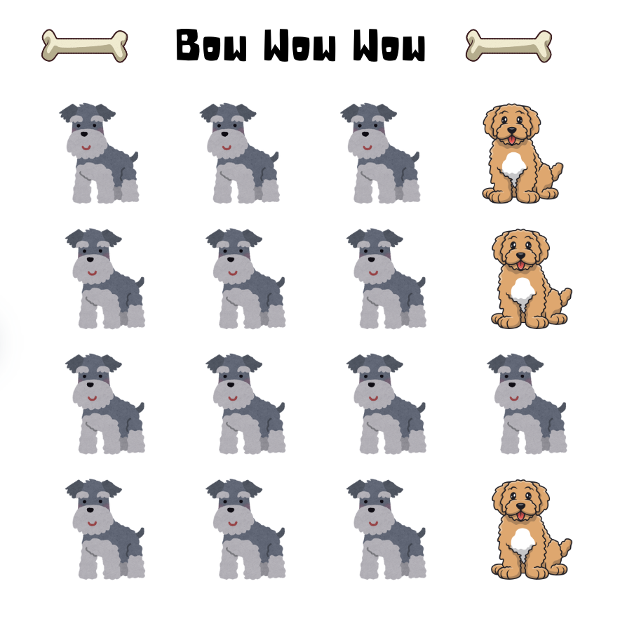

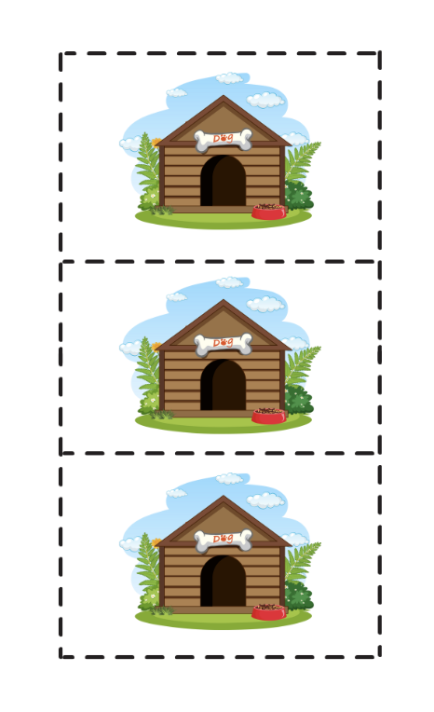
Trim the dog houses below to cover the different looking dogs (rests) on rows 1, 2, and 4 on the tap sheet above.

Second Grade Bow Wow Wow Solgége

Student Solfége Sheet (Easy)



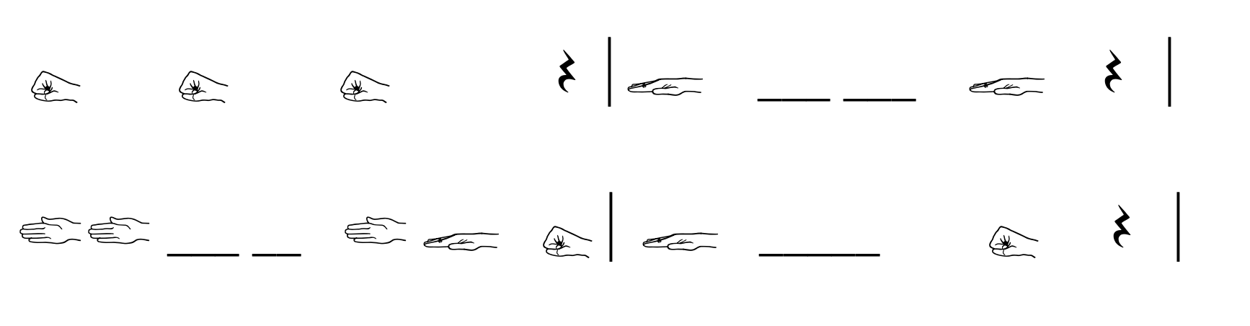

Student Solfége Sheet (Difficult)

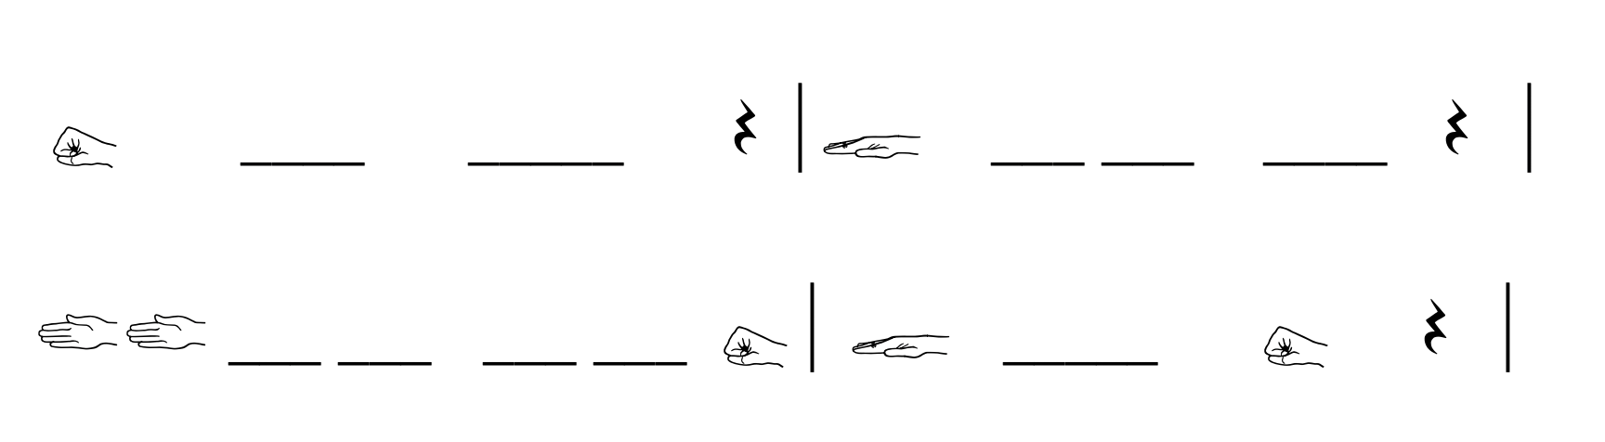

Solfége Key
