

Music In Our Schools Month Lesson for 4th and 5th Grades
Curriculum Design: Using the Same Repertoire for Many Purposes
Question and Answer Improvisation
(60 minutes)

Submitted by BethAnn Hepburn, North Central Division Representative of NAfME General Music Council

Objectives:

Improvisation:
- Students will use a blues scale to improvise melodies in question and answer form.
- Students will improvise 16 beat phrases over a moving bass line.

Form:
- Students will identify A B large form.
- Students will identify a question-and-answer phrasal form.

Expression:
- Students will use a swing-style rhythm when improvising.

Materials, Equipment, Books
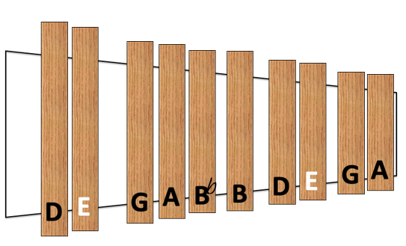
- A slide of a blues scale on the xylophone
- Pitched Percussion Instruments (i.e., Xylophones, Metallophones, Glockenspiels, etc.)
- Optional: drum set

Repertoire
- Rhyme & Melody: Walkin’ on Down to Basin Street, BethAnn Hepburn

Lesson Procedure
*Below is an example of how a song can be used in the music classroom for various purposes. The activities below can be modified and adjusted as needed.

The Bass Line (Movement Eurhythmics Quick Reaction Warm-Up)

- Students (S) begin in scattered space around the room, Teacher (T) plays the bass line on a bass xylophone or piano.
- T. establishes the 3 pitches of the bass line by having students change direction on each pitch (E, A, and B) from the bass line.
- T. plays the bass line while the students walk on the beat, changing directions with each pitch change.
- Repeat the process and focus the students’ attention on how many beats they move each direction until they know the bass line pattern.
- Transfer the pattern to the Bass Xylophones by having a few students play the bass line.

The A Section Melody: Prepare the stepwise motion with movement.

- T. models using the whole body to outline the stepwise motion of the melody.
- Snap the rhythm of the E’s above your heads, then twist and come down towards the ground.
- EE then go all the way down (rest) E E then go all the way up. Repeat twice
- Students move while the teacher plays the melody on the xylophone and chants the text while students are moving.

Walkin’ on down to Basin Street, where the music moves you from your head to your feet
Walkin’ on down to Basin Street, syncopated music just can’t be beat!

- Students chant the words in rhythm and pat the rhythm on their legs. Practicing this rhythm alternating will help prepare the mallets alternating.
- Transfer to the xylophones.
- Play these two measures twice for the A section.
- Add the xylophone melody to the bass line, and if available, add a swing rhythm on the drum set.

Question and Answer Improvisation

- The teacher models question and answer improvisation for the class: focus their listening by asking “tell me something you notice about my improvisation”. Model a melody with a swing rhythm that starts and stops on the tonal center (E), use many step-wise notes in the melody and add melodic sequences.
- Once the students notice the starting note is E, the rhythm is syncopated or swings, and the mallets are alternating often with stepwise motion, they are ready to be the answer to the teacher’s improvised question.
- The teacher is the question for 16 beats, and the students give a melodic answer.
- Repeat the process, but have the students be the question and the teacher is the answer.
- Next, pair students: one student is the question and the other is the answer.
- Allow time for students to practice with their partner.

Review the Large Form A section, and practice going right into the question and answer B section.

Final Performance
- Perform the A section as an entire class with the moving Bass line, and xylophones on the melody and add the drum set or swing rhythm on a tubano or other drum. Alternate the A section with paired partner soloists as the B section improvising questions and answers.

