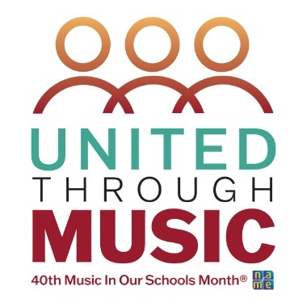

Music In Our Schools Month Lesson for 4th Grade
Curriculum Design: Using the Same Repertoire for Many Purposes
“United in Music: Singing, Moving and Playing Together”

Submitted by Becky Halliday, Southern Division Representative of NAfME General Music Council

Objectives:

- Students will improvise movement that reflects a variety of positional levels, weighted movements, and space.
- Students will respond to the formal structure of a folk dance through choreographed and improvised movement.
- Students will improvise in question/answer form.
- Students will create movements that reflect the formal structure of a binary piece of music.

Materials, Equipment, Books
- Hand Drum (for teacher use)
- Orff instruments/non-pitched instruments as available

Repertoire
- Down the River (available in a variety of songbooks/resources; folk dance may vary)

Lesson Procedure
Take a Walk
- Teacher (T) plays steady beat on hand drum; students respond by walking
- T instructs students to try a different movement with the steady beat, giving directions for them to try:
  - Low/high/medium levels of movement
  - “Big” and “little” movements
  - Different weights of movement: heavy, light, etc.
- T plays ta-ti pattern that reflects 6|8 meter; students respond with a self-chosen change of movement (gallop, slide, skip, etc.).
- T acknowledges students’ responses; one is chosen.
- T alternates between the two patterns; students respond.
Down the River
- T teaches “Down the River” by rote; students aurally identify A and B sections.
- Students choose a partner; stand shoulder to shoulder in a long line facing the same direction.
- One partner steps out and faces their partner, creating a longways set.
- Head couple is identified.
- A section (Verse): 4 steps forward, clap both partner’s hands on beat 4; 4 steps back, clap own hands.
- B section: Head couple chooses a movement and sashays down the line for 8 beats, with the next couple following behind doing the same movement.
Create a binary piece
**Note: if no instruments are available, body percussion or found sounds can be used.
- Teacher leads a musical Question/Answer using quarter/paired eighth rhythm patterns - first 4 beats, then 8 beats. Teacher gives the first pattern, students respond with an improvised pattern based on the first.

Examples:

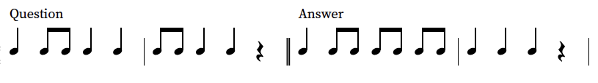
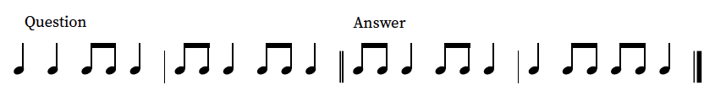
- Each half the class is given same or similar instruments (pitched or non-pitched, as available)
- If using Orff instruments (suggested: C pentatonic):
  - Bass instruments play macrobeat bordun
  - Metallophones play a given rhythm pattern - last note should be /so/
  - Xylophones respond with an improvised response - last note should be /do/
- Pull out 2 groups for movement. Each group decides on movement to reflect one of the sections of music. A section: Locomotor; B section: Nonlocomotor.

Alternatively:
Q & A could serve as an interlude between the 2 verses of “Down the River” (G pentatonic suggested)

