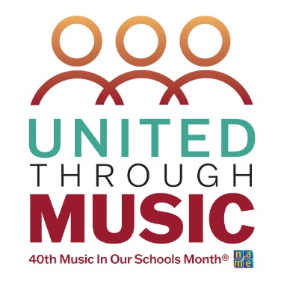

Music In Our Schools Month Lesson for Kindergarten
Curriculum Design: Using the Same Repertoire for Many Purposes

Submitted by Stephanie Benischek, NAfME General Music Council Chair

Objectives:
- Students will use their singing voice and speaking voice.
- Students will create a shape using pipe cleaners (or yarn).
- Students will demonstrate melodic contour by singing their shape in an “ooh” voice.
- Students will perform a movement activity with A and B sections.
- Students will guess who wakes them up by the sound of the person’s vocal timbre.
- Students will compare higher and lower sounds in a variety of musical examples.
- Students will respond to lower and higher sounds in a recorded example by playing low (drum) and high (triangle) instruments.

Materials, Equipment, Books
- Pipe Cleaners or yarn
- High and low instruments, such as triangles and drums
- Recording of Blue Danube

Repertoire
- The More We Get Together
- Hunt the Cows by Jean Ritchie
- The Beautiful Blue Danube, Waltz 314 by Johann Strauss II recording

Lesson Procedure
The More We Get Together, welcome to music song
- Sing the song with students.
- Allow all students to say their names on the B section (for Emma’s with Hector, and Maya’s with Jackson, etc.)

Pipe Cleaners, Creating activity
- Teacher will demonstrate how to manipulate a pipe cleaner into shapes with high and low. What does this sound like? Use your “ooh” voice.
- Teacher will pass out a pipe cleaner or an 8 inch piece of yarn for students to manipulate into high and low shapes. Students create their own shape. Use an “ooh” singing voice to show how the shape goes higher and lower.
- Show a friend your example and what it sounds like, then listen to their example.
- Compare: Whose example was higher? Whose was lower?

Hunt the Cows, movement activity
- Teach the song and explain there are two parts. In the A section, we will walk around the room and look for the cows. On the B section, we are tired, so we slowly go down to the ground and fall asleep. Someone will wake us up by saying “Wake up, lazy bones.” Will you be able to guess whose voice it is without looking?
- Play the game. In the B section, students add an action on each phrase. In the first phrase, students will put one knee on the floor, two knees on the floor, then one elbow, then lay down and pretend to sleep. One student will get chosen to say “Wake Up Lazy Bones” by being tapped on the back. Students laying down try to guess who is waking them up by their voice before looking.
- Let the game repeat so several students have a turn to wake up the class.
- Return to seats. Talk about the B section of the song: The cows are gone, the sun is hot, etc. Where are the low notes? Where are the high notes? How do you know?

The Beautiful Blue Danube, Waltz 314 by Johann Strauss II, listening activity with instruments
- Show the students two instruments that produce a high sound (such as a triangle) and a low sound (such as a drum). Explain that some students will receive a low instrument on one side of the room and others will receive a high instrument.
- Practice: low low low low low high high, high high
- Play the Blue Danube by Stauss. Start the music at approximately 1:30 (depending on your version’s tempo) where the waltz begins. Direct the children with low instruments to play, then the high instruments to match the music.
- If you have time, you may repeat the exercise with the students switching to the other instrument.

Adjusting objectives to reuse repertoire for older grades:

- The More We Get Together is a great song in ¾ time signature. You can have students perform body percussion, such as pat, clap, snap on beats one, two and three or play sticks on the floor for the downbeat and click in the air on beats two and three.
- I enjoy using pipe cleaners for kindergarten melody creation. In first grade, we eventually switch to other manipulatives such as bingo chips to show so and mi pitches.
- Wake Up Lazy Bones can be adapted in many ways. In addition to teaching AB form and high low in kindergarten, you can use the song in first grade to read quarter notes and eighth notes. If your curriculum includes tempo markings such as allegro, moderato, and largo, you can enjoy changing the A and B sections to different tempos. If you teach solfege, the B section is an excellent example of so do.

