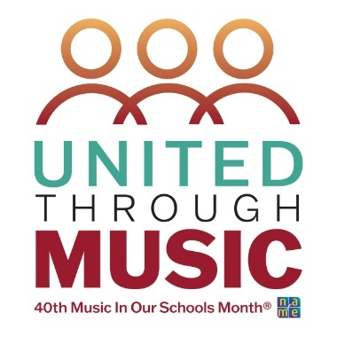

Music In Our Schools Month Lesson for 2nd Grade
Curriculum Design: Using the Same Repertoire for Many Purposes

Submitted by Gail Shriver, Southwestern Division Representative for NAfME General Music Council
Objective:
- Students will echo sing on so-mi.
- Students will create quarter note (ta), eighth notes (ti-ti), and quarter rest rhythms using popsicle sticks.
- Students will respond to music using a stretchy band.
- Students will clap and stomp phrases heard in a book.

Materials, Equipment, Books
- Music for Welcome to Music and Driving Our Car
- Computer and speaker
- Popsicle sticks in ziplock bags. (Having the sticks already divided and in baggies makes it easy for the students to get their supplies, begin their activity, and great clean up.)
- Book - Mitchell’s License by Hallie Durand
- Hand Drums
- Egg Shakers

Repertoire
- Welcome to Music by Denise Gagne
- Driving Our Car by Stephanie Leavell
- Mitchell’s License, book

Lesson Procedure
Welcome to Music, welcome song
- Stand and sing
- Following the welcome song, the students answer roll call. I use a puppet named
Mr. Greg, who sings the student’s names on sol-mi. The students answer with “I’m here,” also on sol-mi. (Pitch matching assessment).
Popsicle Stick Rhythm Writing
- Using stand up, hand up, pair up, students will find a partner and find a place in the room to sit together.
- Playing “Rock, Paper, Scissors,” students will decide which student will be Partner A.
- Partner A will come to the front of the room and collect their popsicle sticks from the bin.
- Partner A will return to their partner and notate a 4 beat pattern using popsicle sticks to form ta, ti-ti, or ta rest.
- Partner B will clap the rhythm and determine if it is 4 beats. If the pattern is not correct, the students will discuss how to make it correct.
- Next Partner B will create a different 4 beat pattern,
- Partner A will clap the rhythm to determine if the rhythm is correct.
- Partner B will return the sticks to the bin.
Driving Our Car, movement
- Teach the song and discuss what it would look like if we were driving a real car.
- Sing and use the actions.
- Have students move to sit in a large circle.
- Add a giant stretchy band.
- Ask how our actions change as we all hold onto the stretchy band. Talk about how we now are all driving one BIG car and we must drive together!
- Sing the song and use the band for our actions.
Mitchell’s License, read aloud
- Students move to the reading center, remembering how close we may sit to the reader.
- Teacher reads, “Mitchell’s License” by Hallie Durand.
- Discuss with the students some phrases that they heard.
- Practice saying 1 of the phrases.
- Now pat the rhythm on your knees as you say it.
- Now clap it.
- Now stomp it.
- Repeat this process with the 2nd phrase.
- Divide students into two groups.
- Transfer one of the phrases to the hand drum group.
- Transfer another phrase to the egg shaker group.
- After playing these instruments for a few times, allow the students to trade instruments and play the new rhythms.

Modifying the lesson objectives for 3rd grade:
Learning Target: Tie and Syncopation. Welcome to Music.
Instead of notating the rhythms with popsicles sticks, the students will use white boards with the staff and dry erase markers to notate. We increase the number of beats, creating measures, adding ties, and single eighth notes.
Divide the students into groups of four or five and have them create an ostinato about cars/driving. Maybe it’s a list of their favorite cars or about a road trip. Determine what instrument each group will use, then transfer each group to their instruments. Students will create a melody and movement to complete the composition.
Ukuleles: 4th quarter, Driving Our Car - D Chord and G Chord

