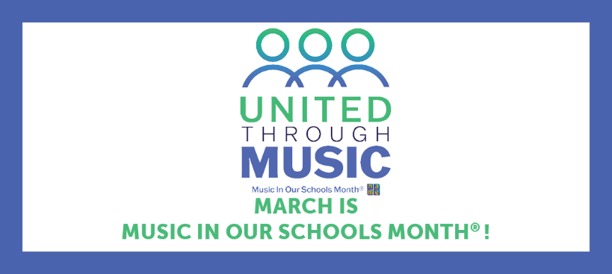
The passage of a proclamation or resolution in recognition of Music In Our Schools Month® is a great way to bring public awareness to the importance of music education in our schools. To determine whether a proclamation or resolution is needed depends on the group or organization that you plan to work with.

Proclamation vs. Resolution?
A proclamation is a public announcement from an official that recognizes an initiative or observance. Proclamations are typically signed by governors, mayors, principals, or other decision-makers who do not require input from others to make an executive decision.
E.g.: A public announcement recognizing March as Music In Our Schools Month, made by your state’s governor, would be a proclamation.
A resolution is a document in which a governing body expresses an opinion or purpose related to a given matter that is temporary in nature. Resolutions are issued by groups governed as a collective, such as school boards, legislative bodies (i.e., local/state/federal legislatures), or Parent-Teacher Associations.
E.g.: A document issued by your local school board for the purpose of designating March as Music In Our Schools Month, would be a resolution.

Step-by-Step Process
- Identify the decision-maker(s) with whom you want to work to pass the resolution or proclamation.
- Brainstorm with other advocates as well. See examples above. Things to keep in mind:
  - What is the end goal of the proclamation/resolution?
  - Who is affected by the proclamation/resolution (a single school, whole school district, entire state, etc.)?
- Introduce yourself to the decision-maker(s)
  - Visit the decision-maker’s(s’) website for more information on requirements and how to submit your proclamation/resolution.
    - E.g.: The New Jersey Governor requires resolutions to be submitted through an application on their website and provides important information on submission deadlines and types of resolutions the Governor is willing to support. New Jersey Application form
  - If you are unable to directly connect with the decision-maker(s), try connecting with an assistant, secretary, educational liaison, or another point of contact.
- Find out what support/help your contact can provide.
- Present your resolution/proclamation to the person you believe will be most helpful in “shepherding” the project along.
  - This will most likely be the point of contact with whom you were able to get in touch from step 3.
- Be open to re-wording your resolution/proclamation, if necessary, as long as the outcome is still valuable.
- Follow your resolution/proclamation as it goes through the process of being accepted. Be prepared to show local support (phone bank, letter campaign, etc.) in case there are obstacles that would hinder the resolution/proclamation from being passed.
- Please share any passed resolution/proclamation from your city/locality, state, or communication from your U.S. Representative or Senators with NAfME by emailing advocacy@nafme.org.

